Thermodynamic Justification:

Review of a Dehydration Reaction

*Nafis Mukut, Coral Pichardo, Justyn Cespedes*

Department of Chemistry, St. John’s University

ABSTRACT

Two different mechanisms were proposed for a dehydration reaction, one being an E1 mechanism, the other being an E2 mechanism. The E1 mechanism was the one determined to be the more likely of the two, as an E2 mechanism required a strong base in order to dehydrate the alcohol in the reaction, which water isn’t. Taking this into account, both mechanisms were analyzed via Gaussian to determine the thermodynamic parameters (internal energy, enthalpy, free energy, & entropy) found in both. This includes analyzing both the individual molecules, and each step taken in each mechanism. By observing the changes in enthalpy and entropy, it was determined that the E2 mechanism was the more thermodynamically favorable of the two. Because the E2 mechanism is thermodynamically favorable, yet not kinetically favorable, it can be concluded that the E2 mechanism would need an unreasonable amount of time to be considered the more favorable of the two.

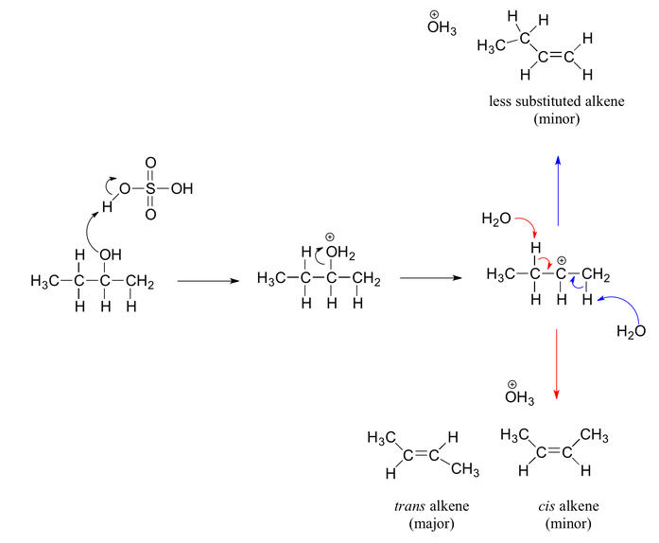

**Figure 1.** Example of a how secondary/tertiary alcohol dehydrates through the E1 mechanism1

INTRODUCTION

Two mechanisms were proposed by a group for a given dehydration reaction of an alcohol, shown in figure 1. The dehydration of an alcohol can undergo either an E1 or E2 mechanism, creating an alkene in exchange for the loss of a created water molecule.2 An E1 mechanism begins with the creation of a carbocation through the loss of a leaving group (alcohol in this case), and the creation of the alkene through having a base to remove the proton from the carbocation.2 An E2 mechanism is a single step; the base removes a proton that is anti to the leaving group, creating the alkene in one concerted step.2 As such, the group also proposed the E1 and E2 mechanisms displayed in schemes 1 & 2.

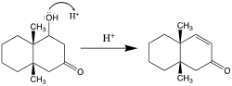

**Figure 2.** Dehydration reaction proposed by group.

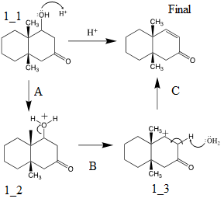

**Scheme 1.** E1 mechanism for the proposed dehydration reaction.

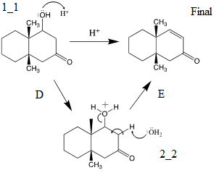

**Scheme 2.** E2 mechanism for the proposed dehydration reaction.

Of the two mechanisms, scheme 2 was determined to be the less favorable of the two, as the E2 mechanism required a strong base in order to dehydrate the alcohol, which water is not.

This report is aimed to collect and use electronic structure calculations in order to compare the thermodynamics found within both mechanisms, and see which of the two are more thermodynamically favorable. This is done through obtaining the internal energy, enthalpy, entropy, and Gibbs free energy. Whilst typically, only Gibbs free energy is needed to determine whether or not a reaction is thermodynamically favorable, obtaining the other values for the overall reaction, as well for each individual component and step can further support each mechanism’s case through the Gibbs free energy equation.

∆G=∆H-T∆S (1)

As shown in equation 1, both entropy and enthalpy directly influence Gibbs free energy, and as such, are significant when determining whether or not a reaction is thermodynamically favorable. If ∆H is a negative value, whilst ∆S is a positive value, the reaction is always favorable.3 If the opposite is true, then the reaction is never favorable.3 If both have the same sign values, then the favorability is dependent on temperature.3

As such, determining these values utilizing electronic structure calculations will give a better understanding between both of these proposed mechanisms.

COMPUTATIONAL METHODS

For this report, GaussView was used to build each molecule used in each step of this reaction, including H2O and H3O+ (to provide H+).4 Each molecule had their internal energies, enthalpies, entropies, and free energies calculated through this program.

Each molecule had the following operations performed on it: optimization, energy, and then finally, optimization with frequency. All calculations were initially done with Hartree-Fock, using the basis set of 3-21G. From this set, further sets were used scaling up from 3-21G to 6-311G (for 2d, 2p). By having used each basis set, the molecules would be in their most stable forms prior to being optimized. For these calculations, the method of Hartree-Fock was initially used, in addition to DFT (Density Functional Theory). These methods were used due to their convenience; as they would use the least amount of time when performing these calculations on each molecule.

RESULTS & DISCUSSION

All data was organized in Excel in order to calculate the changes in enthalpy, entropy, internal energy, and free energy which occurs in each step of each mechanism, and the overall reactions.

**Table 1.** Thermodynamic values calculated from GaussView. Each structure label matches that of the schema above. Structures 1_2 & 2_2 are effectively the same, and thus, share a row.

|  |  |  |  |  |
| --- | --- | --- | --- | --- |
| Structure | EE+ Thermal Energy Correction (Hartree) | EE+ Thermal Enthalpy (Hartree) | EE+ Free Energy (Hartree) | Entropy (cal/(mol*K)) |
| 1_1 | -619.640326 | -619.639382 | -619.692146 | 111.052 |
| 1_2 & 2_2 | -620.029141 | -620.028197 | -620.082329 | 113.930 |
| 1_3 | -541.092175 | -541.091230 | -541.142126 | 107.119 |
| Final | -544.405306 | -544.404362 | -544.454798 | 106.150 |
| H2O | -76.402227 | -76.401283 | -76.422716 | 45.110 |
| H3O+ | -76.792554 | -76.791610 | -76.814182 | 47.507 |

**Table 2.** Calculated changes in internal energy, enthalpy, free energy, and entropy for each step, as well as the overall reaction for both mechanisms.

|  |  |  |  |  |
| --- | --- | --- | --- | --- |
| Reaction/Reaction Step | $Δ$ E (kJ/mol) | $Δ$ H (kJ/mol) | $Δ$ G (kJ/mol) | $Δ$ S (kJ/mol) |
| Overall E1 (Initial and Final) | 152.0276 | 152.0266 | 152.0515 | -52.409 |
| Overall E2 (Initial and Final) | 152.0276 | 152.0266 | 152.0515 | -52.409 |
| Step A | 76.40374 | 76.4028 | 76.424 | -44.629 |
| Step B | 2.534739 | 2.535684 | 2.517487 | 38.299 |
| Step C | 73.0891 | 73.08815 | 73.11004 | -46.079 |
| Step D | 76.40374 | 76.4028 | 76.424 | -44.629 |
| Step E | 75.62384 | 75.62384 | 75.62753 | -7.78 |

Utilizing the values from GaussView for each structure in this reaction, the changes in enthalpy, internal energy, free energy, and entropy for each step and overall reaction was calculated for both the E1 and E2 mechanisms utilizing the following formula:

$ΔG= ∑ΔG Products- ∑ΔG Reactants$ (2)

Swapping G out for the respective thermodynamic parameter in question. By looking at these values, it can be seen whether or not the reaction is entropically or enthalpically driven. A reaction can be seen as entropically driven if it’s an endothermic reaction that has it’s positive change in enthalpy countered by a large, positive change in entropy. A reaction can be seen as enthalpically driven if it’s an exothermic reaction, which has a large, negative enthalpy drive the reaction.

Based on the values taken above, it can be confirmed that the overall reaction is enthalpically driven, with each step driven by enthalpy aside from step B, which is driven entropically, as only step B has a large enough entropy value to counteract a positive enthalpy value.

In terms of thermodynamic favorability, it can be determined that mechanism 2 is the more favorable of the two. This is due to the largest jumps taken between each step in both reactions, in terms of Gibbs free energy. In the E1 mechanism, the jump from the lowest change in Gibbs free energy to the next highest is much larger than in comparison to the E2 mechanism, making it clearly the less thermodynamically favorable choice.

CONCLUSION

This report was done in order to thermodynamically compare both of the given mechanisms proposed for the dehydration reaction seen in figure 2. Of the two schemes, scheme 2 was determined to be the more thermodynamically favorable of the two. However, this is the opposite of the theory given by the group; that scheme 1 would be the more favorable of the two, as scheme 2 required a strong base which isn’t present in the reaction. As such, the E2 mechanism can be seen as thermodynamically favorable, yet not kinetically favorable. As such, it’s a slow reaction, one that takes too long to be the more favorable of the two. The strong base is what makes E2 a concerted step. However, using water instead makes it non-concerted, meaning it’s too slow to be considered favorable.

REFERENCES

1. Thuy Hoang, “Alkenes from Dehydration of Alcohols” Chemistry LibreTexts, 5 Jun. 2019, <https://chem.libretexts.org/Bookshelves/Organic_Chemistry/Supplemental_Modules_(Organic_Chemistry)/Alkenes/Synthesis_of_Alkenes/Alkenes_from_Dehydration_of_Alcohols>
2. Jeffrey Ma, “Dehydration Reactions of Alcohols” Chemistry LibreTexts, 11 Jun. 2019, <https://chem.libretexts.org/Bookshelves/Organic_Chemistry/Map%3A_Organic_Chemistry_(Wade)/14%3A_Reactions_of_Alcohols/14.04%3A_Dehydration_Reactions_of_Alcohols>
3. Christine Gobbroge, “Gibbs Free Energy” Chemistry LibreTexts, 22 Jun. 2015, <https://chem.libretexts.org/Courses/Purdue/Purdue_Chem_26100%3A_Organic_Chemistry_I_(Wenthold)/Chapter_05%3A_The_Study_of_Chemical_Reactions/5.2.%09Equilibrium_Constants_and_Free_Energy/Equilibrium_Constants_and_Free_Energy/Gibbs_Free_Energy>
4. Using GaussView 6. (n.d.). Retrieved from<https://gaussian.com/gv6main/>.
5. **Software**: GaussView, Version 16, Dennington, Roy; Keith, Todd A.; Millam, John M. Semichem Inc., Shawnee Mission, KS, 2016.